📘 Jetson Nano + ESP32
Getting Started Guide (Python 3.10 venv + Serial Control)
1️⃣ Overview
This document explains how to:
- Connect Jetson Nano with ESP32
- Use Python 3.10 virtual environment
- Send ON / OFF commands from Jetson
- Control ESP32 built-in LED
- Troubleshoot common errors
This setup is a foundation for:
- Motor control
- Robotics
- YOLO + actuator integration
- Autonomous rover projects

2️⃣ System Architecture
Jetson Nano (Python 3.10 + YOLO)
│ USB Serial
▼
ESP32 (Arduino code)
│
Built-in LED / Motor Driver
- Jetson Nano = Logic / AI
- ESP32 = Hardware control
- Communication = USB Serial
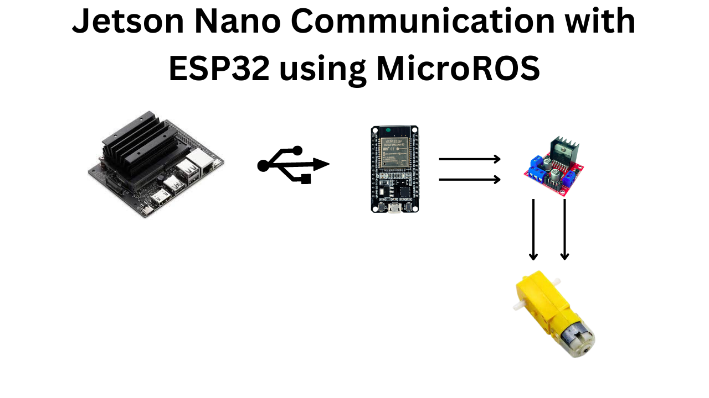
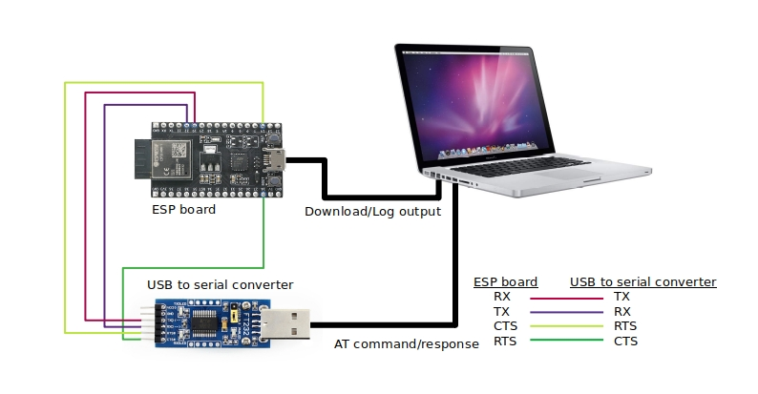
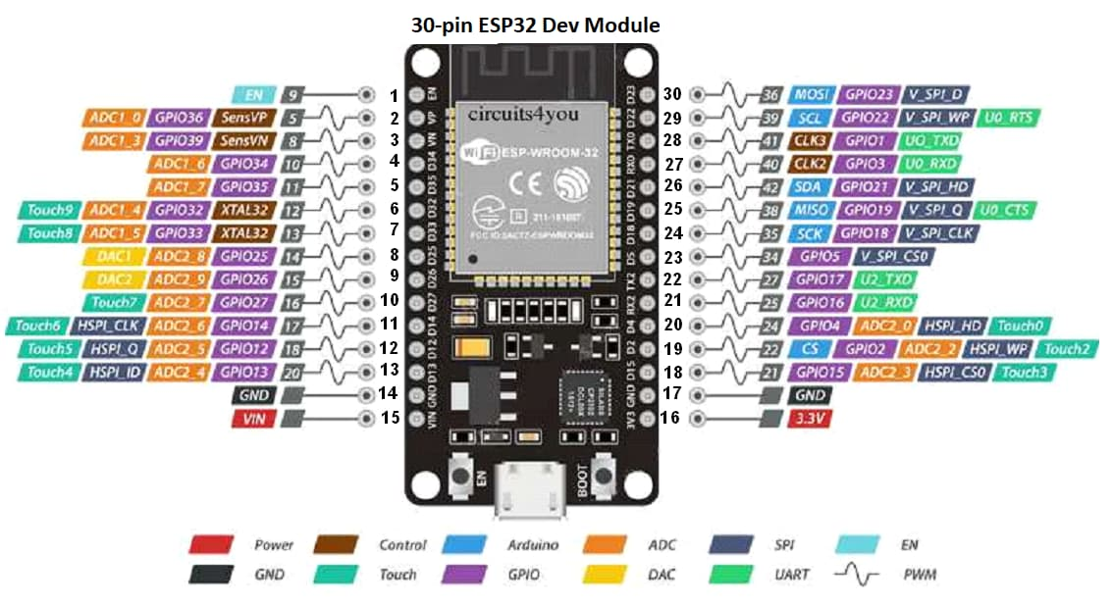

3️⃣ Requirements
🔧 Hardware
- Jetson Nano (Ubuntu) – from NVIDIA
- ESP32 Dev Board – from Espressif
- USB cable (data cable)

💻 Software
- Arduino IDE (on Laptop / PC)
- ESP32 board support installed
- Python 3.10
- Python virtual environment
- pyserial library

4️⃣ Step 1: Upload ESP32 Code (Laptop / PC)
⚠️ Important
ESP32 code must be uploaded from a laptop/PC (one-time step).
ESP32 Arduino Code (LED Control)
#define LED_PIN 2 // Most ESP32 boards

void setup() {
pinMode(LED_PIN, OUTPUT);
Serial.begin(115200);
}

void loop() {
if (Serial.available()) {
String cmd = Serial.readStringUntil('\n');
cmd.trim();

if (cmd == "ON") {
digitalWrite(LED_PIN, HIGH);
}
else if (cmd == "OFF") {
digitalWrite(LED_PIN, LOW);
}
}
}
Upload Steps
- Open Arduino IDE
- Select Board → ESP32 Dev Module
- Select correct COM / Port
- Click Upload
- If needed, hold BOOT button
✅ “Done uploading” = success

5️⃣ Step 2: Connect ESP32 to Jetson Nano
- Disconnect ESP32 from laptop
- Connect ESP32 to Jetson Nano using USB
- ESP32 will appear as a serial device
Check:
ls /dev/ttyUSB*
Usually:
/dev/ttyUSB0

6️⃣ Step 3: Prepare Python 3.10 Virtual Environment
Activate your venv:
source ~/yolo_env/bin/activate
Install pyserial inside the venv:
pip install pyserial
Verify:
python -c "import serial; print(serial.__version__)"

7️⃣ Step 4: Python Code on Jetson Nano
Create esp32_led_test.py
import serial
import time

PORT = "/dev/ttyUSB0"
BAUD = 115200

ser = serial.Serial(PORT, BAUD, timeout=1)
time.sleep(2) # ESP32 reset delay

print("LED ON")
ser.write(b"ON\n")
time.sleep(2)

print("LED OFF")
ser.write(b"OFF\n")
time.sleep(2)

ser.close()
Run:
python esp32_led_test.py

8️⃣ Expected Output
On Terminal
LED ON
LED OFF
On ESP32
- Built-in LED turns ON
- Then turns OFF
✅ This confirms:
- USB serial working
- Python venv working
- ESP32 command parsing working

9️⃣ Common Troubleshooting

❌ Error: permission denied /dev/ttyUSB0
✅ Fix (Permanent)
sudo usermod -a -G dialout $USER
reboot
After reboot:
groups
Ensure dialout is listed.

❌ Error: python-c command not found
✔ Wrong command
✔ Correct command:
python -c "import serial"

❌ Error: ModuleNotFoundError: No module named 'serial'
✔ Install inside venv:
pip install pyserial

❌ LED not turning ON
Possible reasons:
- ESP32 LED is active-LOW
- Try swapping:
HIGH ↔ LOW

❌ /dev/ttyUSB0 not found
Check:
ls /dev/tty*
If ESP32 shows as /dev/ttyACM0, update Python code.

❌ ESP32 resets repeatedly
✔ Add delay in Python:
time.sleep(2)

🔟 How This Scales to Motors
This LED test is exactly the same logic for motors:
LED Test | Motor Control
ON | Forward
OFF | Stop
GPIO2 | Motor driver pin
LED | DC motor
Later:
- Replace LED code with motor driver pins
- Send F, S, R, SPD:150

✅ Final Summary
✔ ESP32 flashed once from laptop
✔ Jetson Nano controls via Python
✔ Python 3.10 venv supported
✔ Serial communication verified
✔ Ready for motor & robotics work

